- How does JVM works internally?
JVM specification: where working of Java Virtual Machine is specified. But implementation provider is independent to choose the algorithm. Its implementation has been provided by Sun and other companies.
An implementation: Its implementation is known as JRE (Java Runtime Environment).
Runtime Instance: Whenever you write java command on the command prompt to run the java class, and instance of JVM is created.
What it does?
The JVM performs following operations:
- Loads code
- Verifies code
- Executes code
- Provides runtime environment
(VVI) JVM provides definitions for the:
- Memory area
- Class file format
- PC Register set
- Garbage-collected heap
- Fatal error reporting etc.
Internal Architecture of JVM. It contains classloader, memory area, execution engine, native method interfaces, and Java Native Libraries.
* Class(Method) area contains runtime constant pool.
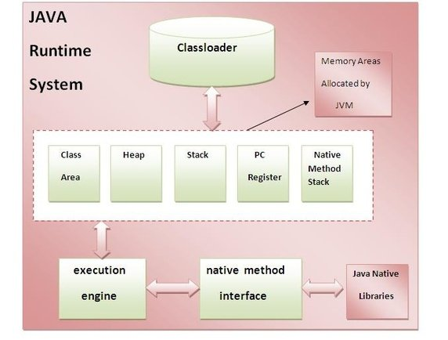

1) Classloader: Classloader is a subsystem of JVM that is used to load class files.
2) Class(Method) Area: Class(Method) Area stores per-class structures such as the runtime constant pool, field and method data, the code for methods.
* Class(Method) area contains runtime constant pool.
3) Heap: It is the runtime data area in which objects are allocated.
4) Stack: Java Stack stores frames. It holds local variables and partial results, and plays a part in method invocation and return.
Each thread has a private JVM stack, created at the same time as thread.
A new frame is created each time a method is invoked. A frame is destroyed when its method invocation completes.
5) Program Counter Register: PC (program counter) register. It contains the address of the Java virtual machine instruction currently being executed.
6) Native Method Stack: It contains all the native methods used in the application.
7) Execution Engine: It contains:
- A virtual processor
- Interpreter: Read bytecode stream then execute the instructions.
- Just-In-Time(JIT) compiler: It is used to improve the performance. JIT compiles parts of the byte code that have similar functionality at the same time, and hence reduces the amount of time needed for compilation. Here the term ?compiler? refers to a translator from the instruction set of a Java virtual machine (JVM) to the instruction set of a specific CPU.
For more details:
http://www.artima.com/insidejvm/ed2/jvmP.html
- Explain JVM run-time data areas:
Understanding JVM run-time data areas are critical to better Java programming. One of the most dreaded errors in Java is OutOfMemoryError and it is related to Java Virtual Machine (JVM) memory areas. We should have better understanding of JVM internals, how its data area works so that we will have better grip over these kind of JVM errors.

Types of Java JVM Run-time Memory Areas:
PC Register
JVM Stacks
Heap Memory
Method Area
Run-time Constant Pool
Native Method Stacks

These six JVM run-time memory areas can be broadly classified into two groups:
Managed per-thread: If the memory area is uniquely allocated for every single thread created. These data area are initialized on thread start and destroyed once the thread completes.
Shared with all threads: If the memory area is common and can be accessed by all the threads. These are initialized when JVM is started and destroyed on shutdown.
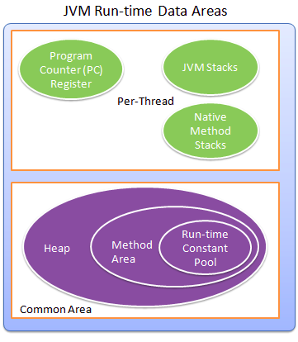

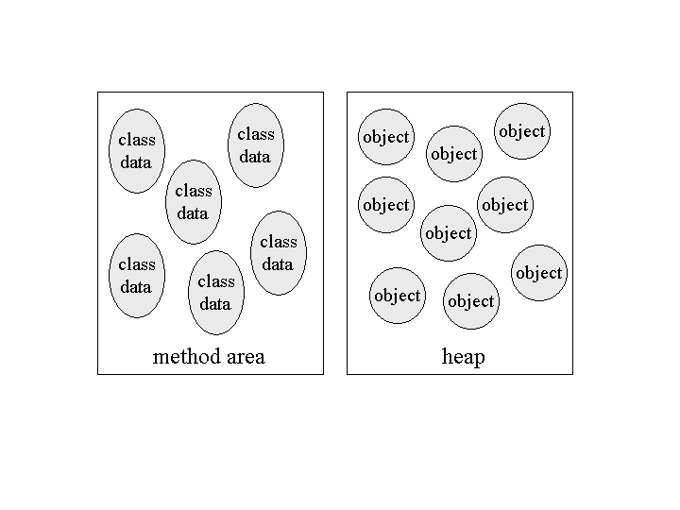

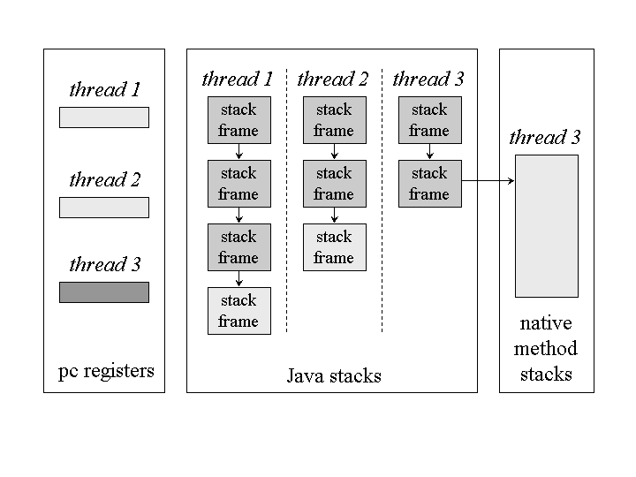

PC Register:
In general computer architecture terms, program counter (PC) register is like a pointer which keeps track of the current instruction executing at any moment.
This is same in Java JVM terms also. We have multithreaded architecture as Java supports multithreading and so, a program counter (PC) Register is created every time a new thread is created. PC keeps a pointer to the current statement that is being executed in its thread.
If the current executing method is ‘native’, then the value of program counter register will be undefined.
JVM Stacks:
JVM stacks are created and managed for each thread. It is used to store a thread's state in discrete frames.
The Java virtual machine only performs two operations directly on Java Stacks: it pushes and pops frames.
The method that is currently being executed by a thread is the thread's current method. When a thread invokes a Java method, the virtual machine creates and pushes a new frame onto the thread's Java stack. This new frame then becomes the current frame. As the method executes, it uses the frame to store parameters, local variables, intermediate computations, and other data.
When a method completes, whether normally or abruptly, the Java virtual machine pops and discards the method's stack frame. The frame for the previous method then becomes the current frame.
Memory size of stacks can be of two types, fixed and varying size. Varying size can dynamically expand as per the need.
StackOverflowError: this error occurs in fixed size JVM stacks, if the memory size is not sufficient during the program execution.
OutOfMemoryError: in dynamic sized stacks, while trying to expand for more memory need and there is no additional memory available to allocate and we get OutOfMemoryError.
Heap Memory:
Heap data area is used to store objects of classes and arrays. Heap memory is common and shared across multiple threads.
This is where the garbage collector comes into picture. This heap area is divided into young gen, old or tenured gen, perm gen, etc.
Heap data area is created at VM startup.
Claiming the memory back is done automatically by the garbage collector (GC). This is one of the best feature of Java. If the allocated memory is not sufficient at run-time JVM can throw OutOfMemoryError.
Method Area:
Method area is created at JVM startup and shared among all the threads.
In general, method area is a logical part of heap area. But that is left to the JVM implementers to decide.
Method area has structures and fields related to per class and per interface (nothing but static fields and structures). It also includes the method data, method and constructor code, run-time constant pool, etc.
JVM will throw OutOfMemoryError if the allocated memory area is not sufficient during he run-time.
Run-time Constant Pool:
Run-time constant pool is created out of the method area and it is created by JVM when a class or interface is created.
Run-time constant pool contains the constant_pool table which is applicable for per class or interface. It contains the literals.
JVM will throw OutOfMemoryError when it cannot find memory to allocate to run-time constant pool.
Native Method Stacks:
JVM that supports native methods will have native method stacks.
It is used for native methods, and created per thread.
If the native methods cannot be loaded by a JVM then it need not have native method stacks.
Memory size is managed similar to general JVM stacks like fixed or dynamic.
JVM will throw StackOverflowError or OutOfMemoryError accordingly.

